# Lab: Unit Testing

This document defines the lab for "Java Advanced" course @ SoftUni

# Part I: Unit Testing Basics

## Create Maven Project

Maven is build automation tool that takes care of dependencies for your project. Before you can make one, make sure that you enable the plugin in IntelliJ **[File 🡪 Settings 🡪 Plugins 🡪 Maven]**

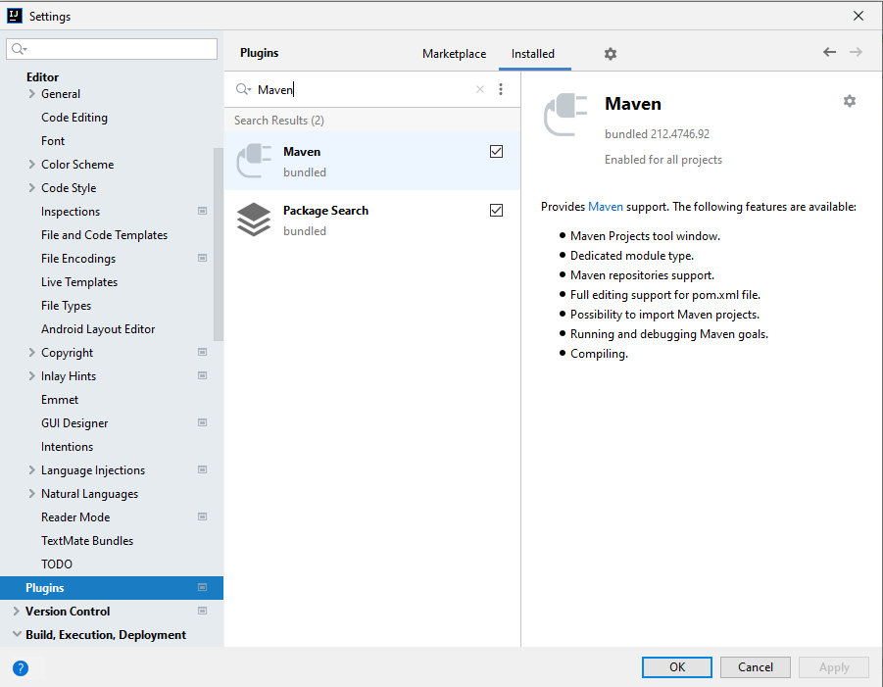

Now, you can create a Maven project.

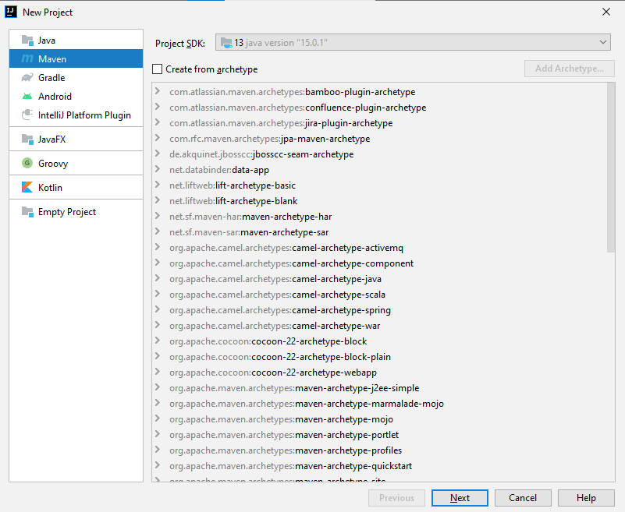

First, you give a name and location to your project. Group Id should be separated by dots, Artifact Id should be separated by hyphens:

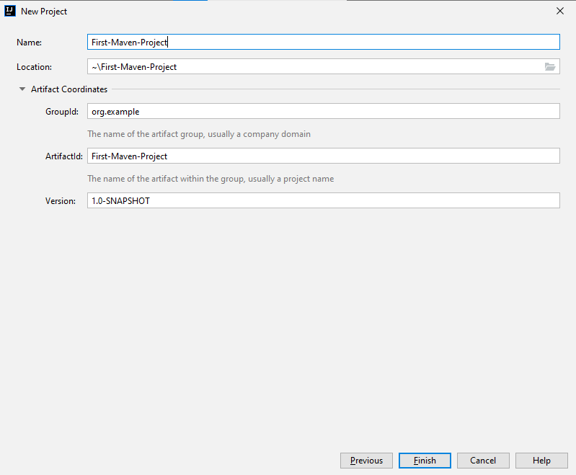aSaa.

If everything is ok, you should see the following project structure:

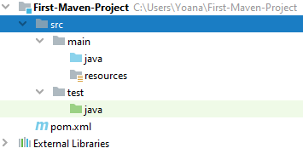

Copy the files provided and place them in a package inside **src/main/java** folder

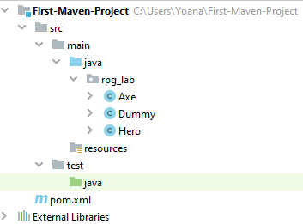

## Test Axe

In the **test/java** folder, create a package called **rpg_tests.**

Create a class **AxeTests.**

Create the following tests:

* Test if the weapon loses durability after each attack;
* Test attacking with a broken weapon.

### Solution

Create the new package **rpg_tests** and inside create the class **AxeTests:**

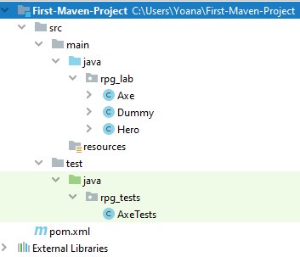

Inside the class create your first test:

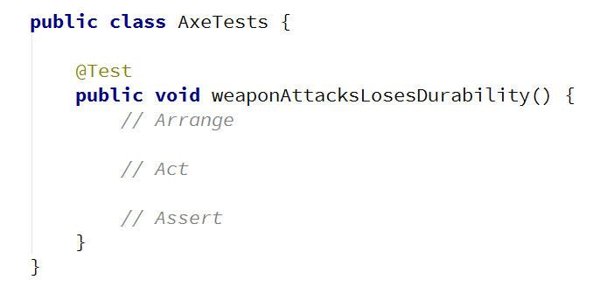

Arrange preconditions:

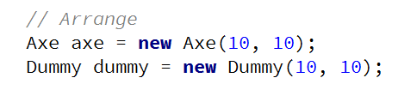

Execute tested behaviour:



Assert postconditions:

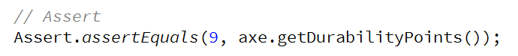

Create your second test method:

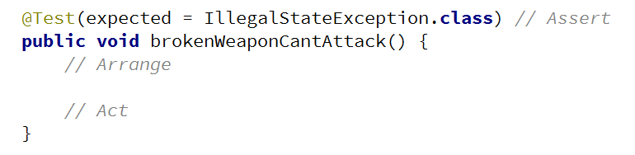

Arrange preconditions and test behaviour:

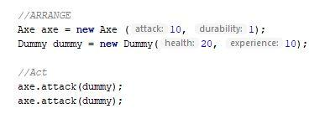a

## Test Dummy

Create a class **DummyTests.**

Create the following tests:

* Dummy loses health if attacked.
* Dead Dummy throws an exception if attacked.
* Dead Dummy can give XP.
* Alive Dummy can't give XP.

### Hints

Follow the logic of the previous problem.

## AB1p

Refactor the tests for **Axe** and **Dummy** classes.

Make sure that:

* **Names** of test methods are **descriptive.**
* You use **appropriate** **assertions** (assert equals vs assert true).
* You use **assertion** **messages.**
* There are **no magic numbers.**
* There is **no code duplication** (Don’t Repeat Yourself).

### Hints

Extract constants and private fields for **Axe** class:

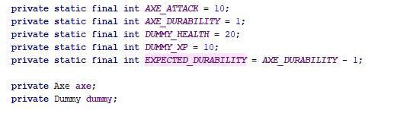

Create a method that executes **before each test:**

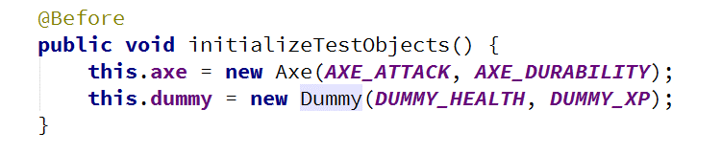

Make use of constants and private fields, as well as add assertion messages:

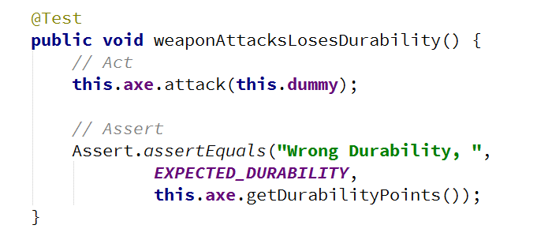

Follow the same logic for other test methods and **TestDummy** class.

# Part II: Dependencies

## Fake Axe and Dummy

Test if the hero gains XP when a target dies.

To do this, you need to:

* Make **Hero** class **testable** (use **Dependency Injection**).
* Introduce **Interfaces** for Axe and Dummy:
  + Interface Weapon
  + Interface Target

Create a fake Weapon and fake Dummy for the test.

### Hints

Create **Weapon** interface:

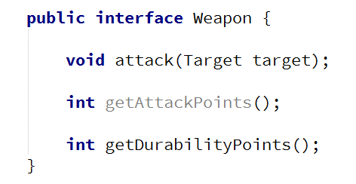

Create **Target** interface:

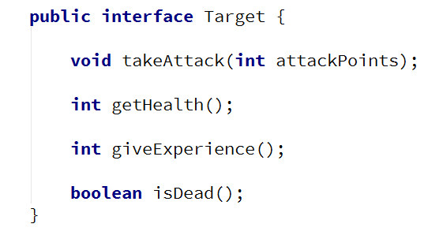

Implement interfaces :



Modify implementation methods to **make use of interfaces:**

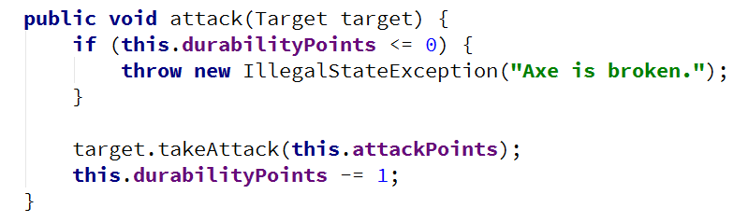

Modify both **Axe** and **Dummy** classes.

Use **Dependency Injection** for Hero class:

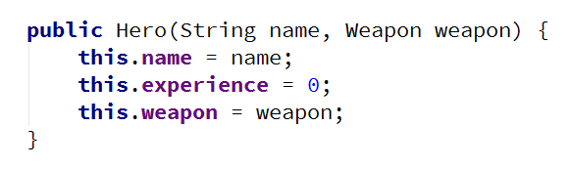

Create **HeroTests** class and test gaining XP functionality by faking Weapon and Target classes:

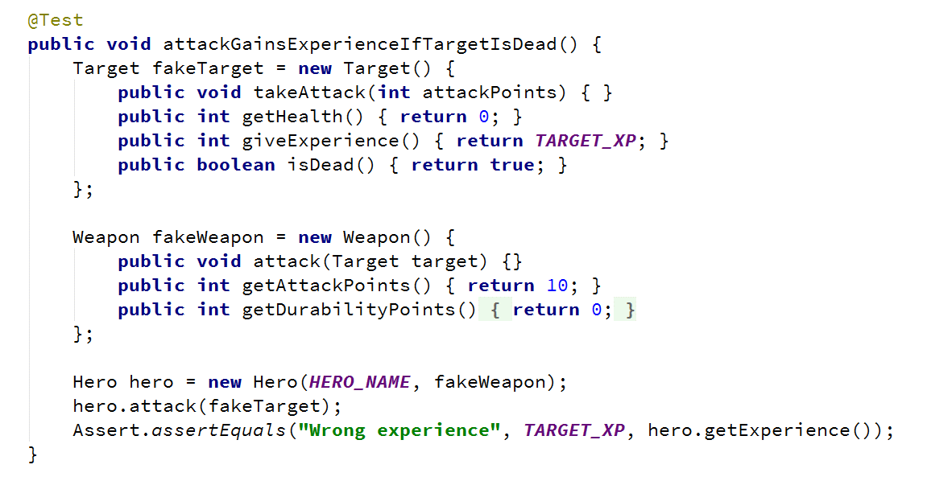

## Mocking

Include **Mockito** in the project dependencies, then:

1. Mock fakes from the previous problem.
2. Implement **Hero Inventory**, holding unequipped weapons:
   1. method - **Iterable<Weapon> getInventory()**
3. Implement Target giving random weapons upon death:
   1. field - **private List<Weapon> possibleLoot**
4. Test Hero killing a target getting loot in his inventory.

### Hints

Locate **pom.xml**.

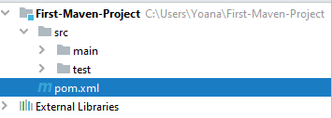

Add **Mockito** dependency.

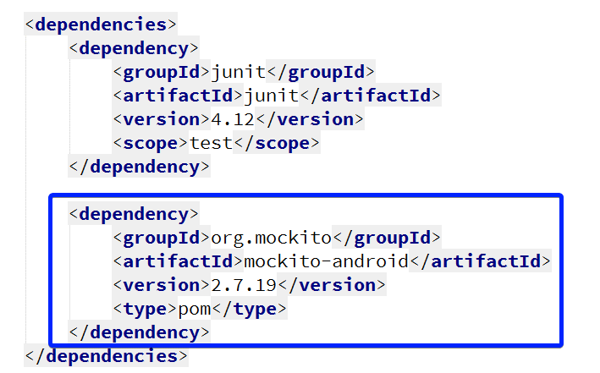

Go to **HeroTests** and refactor the code, making use of **Mockito:**

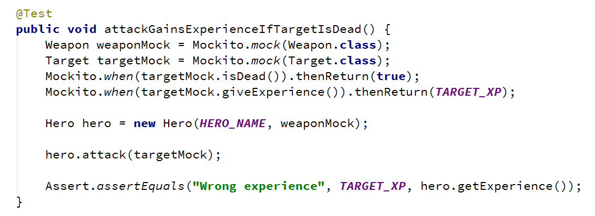

*Implement hero inventory and **Target** dropping loot functionalities.

*Test **Hero** getting loot upon killing a **Target.**